**100% working fixes for windows 11 screen flickering issues -2022**

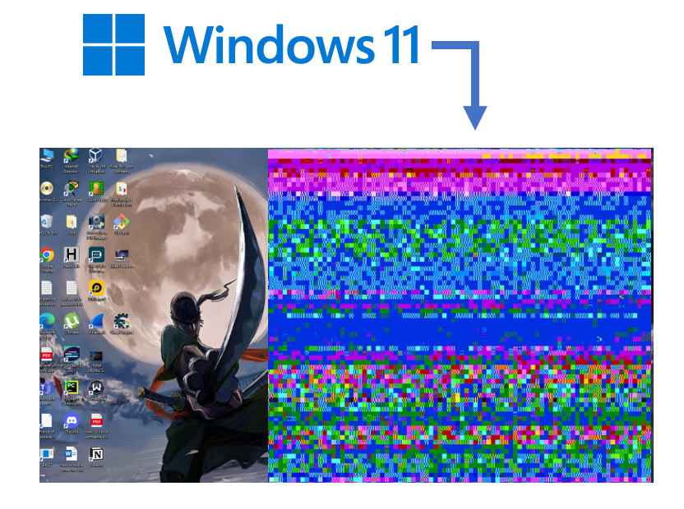

The flickering display problem may arise due to various reasons on Windows 11. So, it is not new news for a windows user. They faced the same issue during the windows 10 update. One of the causes for the flickering issue to arise might be when playing graphically demanding games. Nevertheless, most users faced screen flickering issues when they updated from **windows 10 to windows 11** or when they updated to a newer version of windows 11.

Other causes might be the incompatibility of certain apps with the windows, incompatibility of the new version update with the hardware itself, the fault may lie with the cables, and outdated or corrupt drivers also may trigger the issue.

Whatever the cause, it is such a headache when the screen flickers and you cannot do your work on the PC. So, this article will contain different fixes to solve this issue altogether. Whether it is Dell, Lenovo, or Acer that you are using. The fix works on all.

**We will be looking at seven different fixes.**

**Fix 1 – Disabling Hardware acceleration**

This fix is quite reliable, and users can apply it in their windows 11 instantly without needing to go to any complex settings or near a hardware shop. So, the fix is that they need to disable **hardware acceleration** in windows 11, which is quite simple. The steps are provided below.

**Step 1:** First, right, click on the windows icon, and go to settings.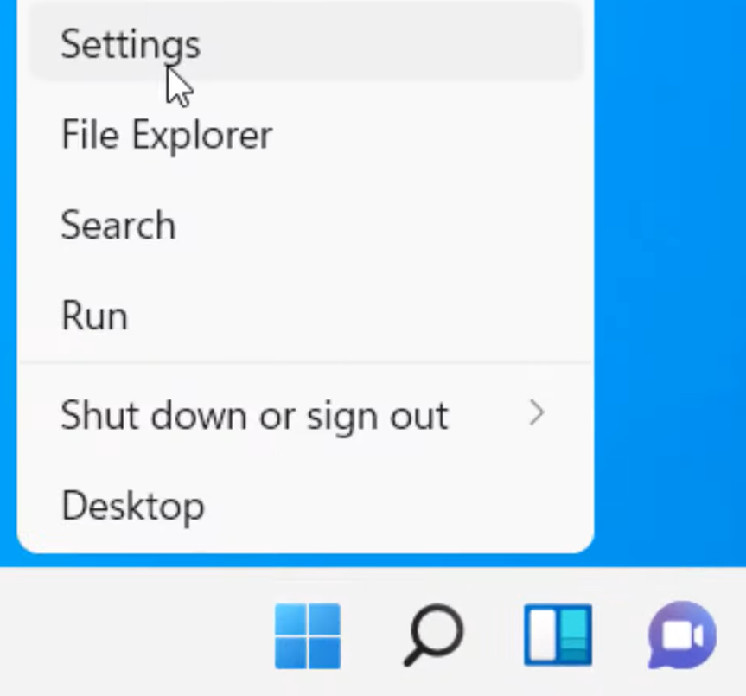

**Step 2:** Select **the system** and choose **the display** to move on to the following process.

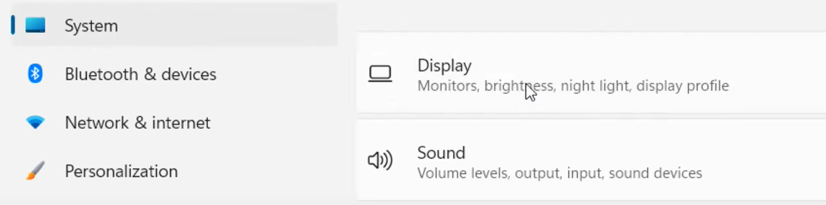

**Step 3:** Scroll down until you find the **“Related settings**” section. There choose **Graphics.**

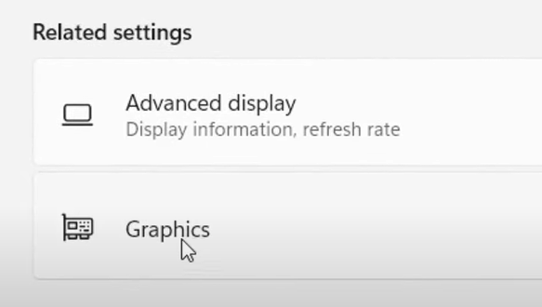

**Step 4:** Click on Change default graphics settings.

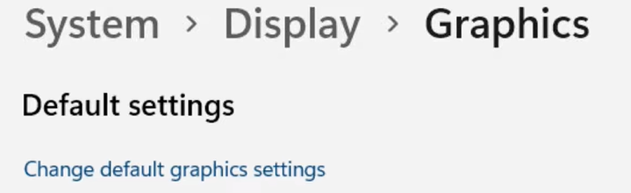

**Step 5:** Turn off the hardware accelerated GPU scheduling and restart your pc to apply the changes. This should solve the issue.

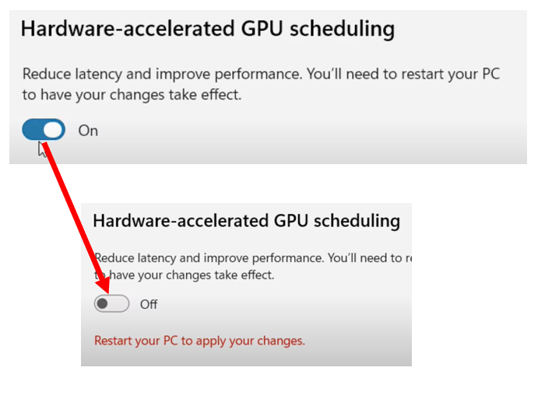

**Fix 2 – Windows Recovery**

If the screen flickers within seconds after booting up and you are not even able to log in to your Microsoft account after booting up due to constant flickering, then you should follow this fix. In this fix, you will need to go into recovery mode. To go to recovery mode, you need to turn off your PC first. So, let us get started.

**Step 1:** First, turn on your computer and wait for the windows logo to appear. As soon as it appears, turn off the PC. You will need to repeat these steps twice. In your third attempt, you will automatically get into the repair screen, which will look like this. After this, click on “**Advanced options.”**

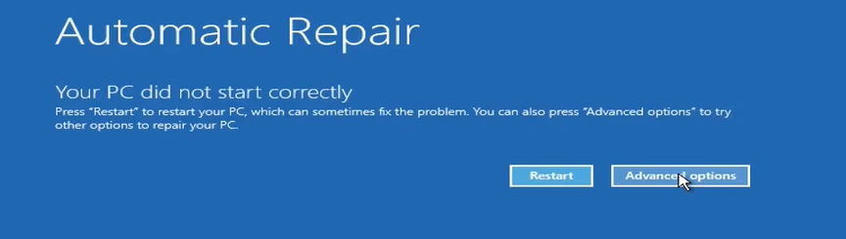

**Step 2**: Choose **troubleshoot option**. Use your keyboard to select this option.

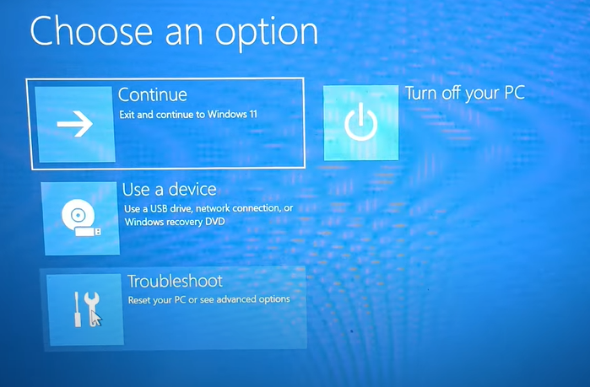

**Step 3**: Under troubleshoot option choose **advanced options**. Use your keyboard to do this task. Do not choose to reset this PC; it will wipe all your PC data. 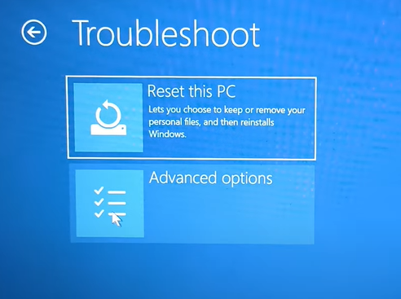

**Step 4:** You’ll see six options to choose from. But for now, choose **uninstall updates.**

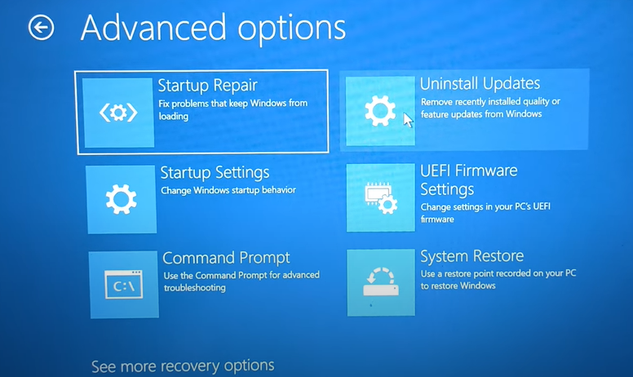

**Step 5**: Then, select **uninstall latest feature update**. The second option.

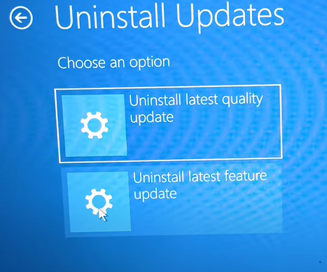

**Step 6:** Uninstalling the latest feature update will uninstall the latest version or the latest drivers installed in windows 11. So, click on **uninstall feature update**. It will take some time; after the process is completed, close it.

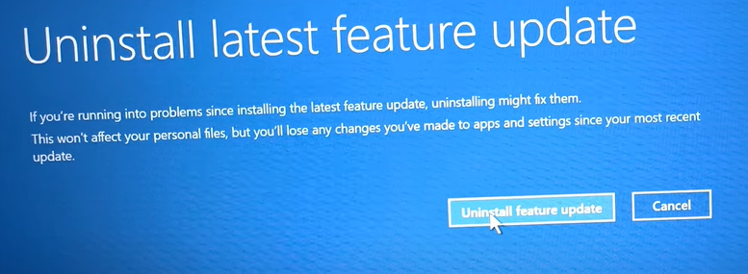

**Step 7:** You will be forwarded to this screen after closing it. From there, select to **turn off** your PC. After this, turn on your PC; your issue is not there anymore.

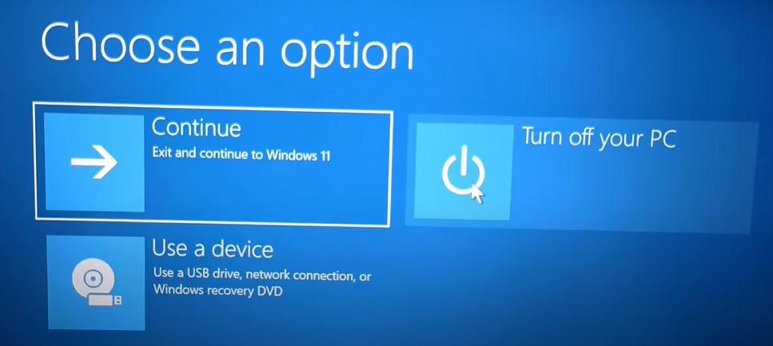

**Fix 3 - Task Manager**

For this, you will need to go to the task manager. If the task manager does not flicker, then you should know that the problem does not lie with the display driver. Instead, a **third-party application** installed on your PC is causing the problem. So, go to your **control panel** and uninstall all the untrusted source apps. If the task manager flickers, you’ll need to update and repair your display driver.

On how to do this, the steps will be shown in **FIX 4.**

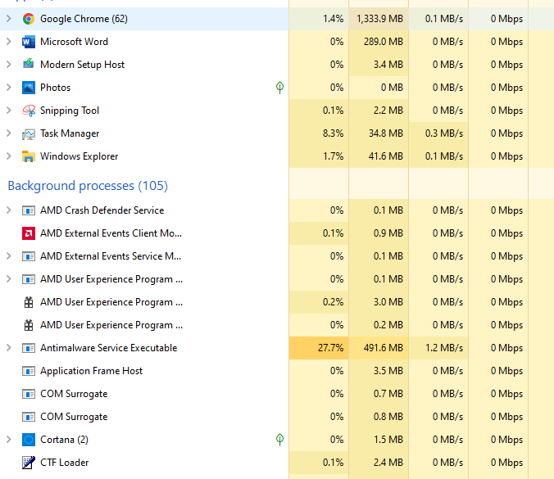

**Fix 4 – Installing AVG Driver Updater**

If you aren’t tech savvy and don’t want to manually repair and update your display drivers then you can download and install automatic driver update software like [**AVG Driver Updater.**](https://www.avg.com/en-us/avg-driver-updater#pc)Through this software you can easily update and repair your display and other drivers automatically.

**Step 1**: Go to [**AVG Driver Updater**](https://www.avg.com/en-us/avg-driver-updater#pc)official site and download it. After that install it.

**Step 2**: After opening the AVG Driver updater you’ll see interface like this. Click on **scan drivers** it will scan your PC to see what drivers to update and repair.

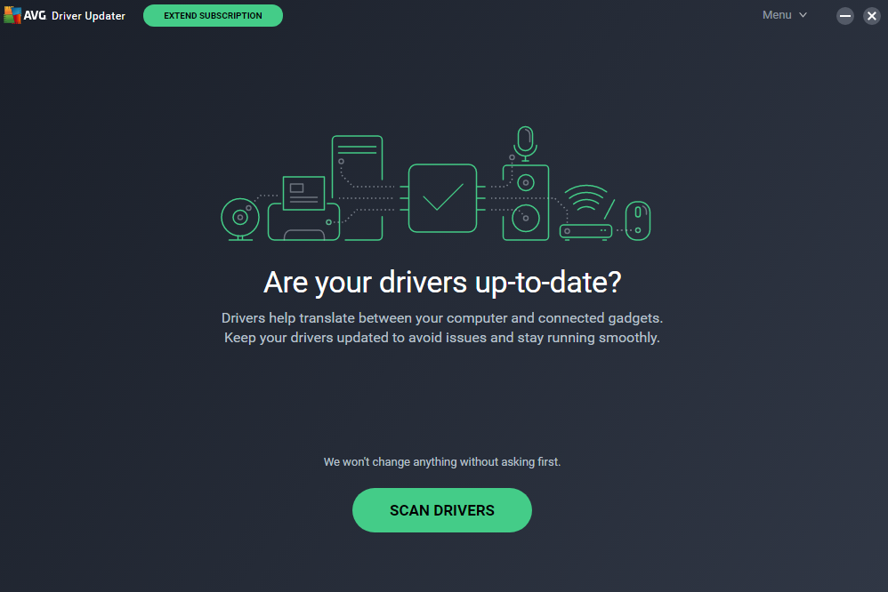

**Step 3:** Check to see if all boxes are ticked or not. If ticked then click on **update selected**. After this all drivers that are needed to your PC will be updated and repaired one by one. Restart your PC to see the change.

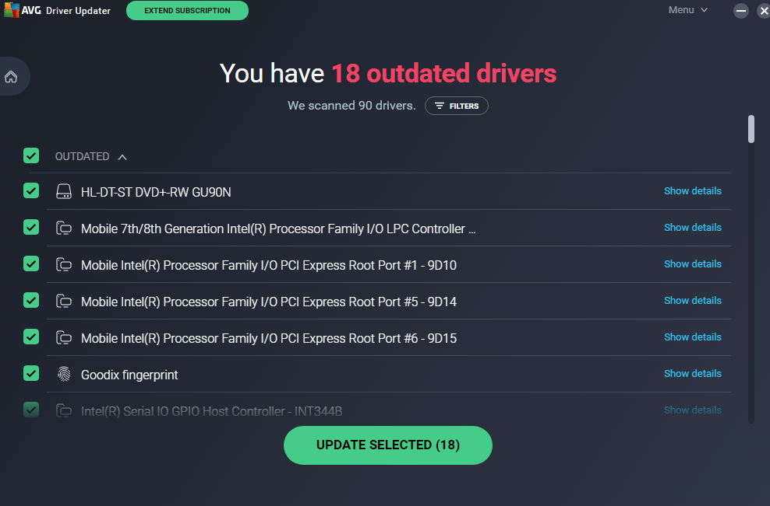

**Fix 5- Changing refresh rate**

If the display is configured incorrectly, going above the recommended refresh rate then the screen flickering issue arises.

**Step 1:** Go to settings and under setting select **system** and choose **display** to move on to the next process.



**Step 2**: Scroll down until you find **“Related settings**” section. There choose Advanced display.



**Step 3:** If the refresh rate is higher then choose a refresh rate 60 Hz or lower.

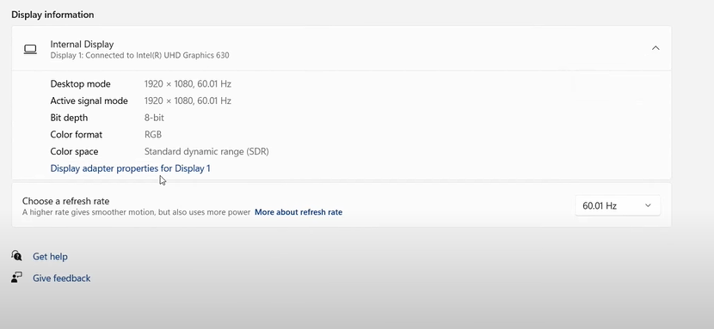

**Fix 6 – Rollback Driver**

**Step 1**: To apply this fix you’ll need to go to device manager. To go to **device manager** just search it in the task bar and open it.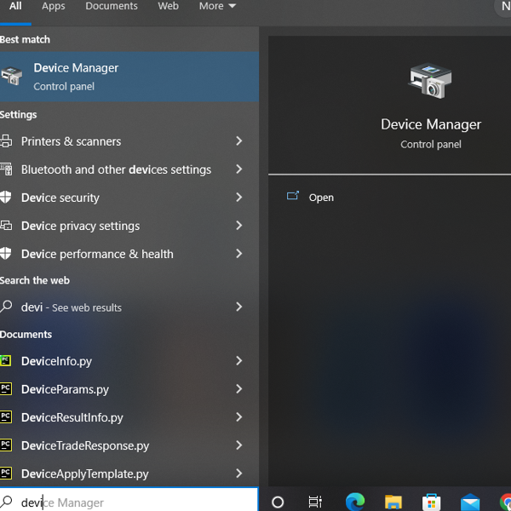

**Step 2:** Select display adapters. Under that choose Intel display adapter. After that, right click on the Intel display adapter and choose properties. After choosing properties the interface will look like this.

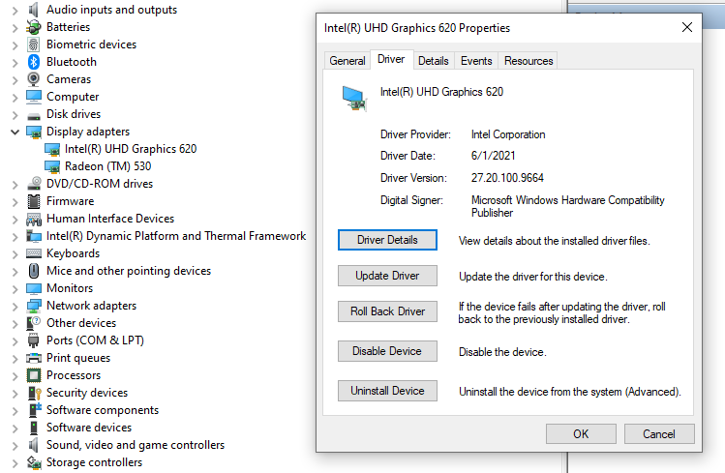

**Step 3:** After opening the properties go to driver section. Under driver click on roll back driver. So, choose your reason to roll back to the previous version and click on yes. Reboot your PC.

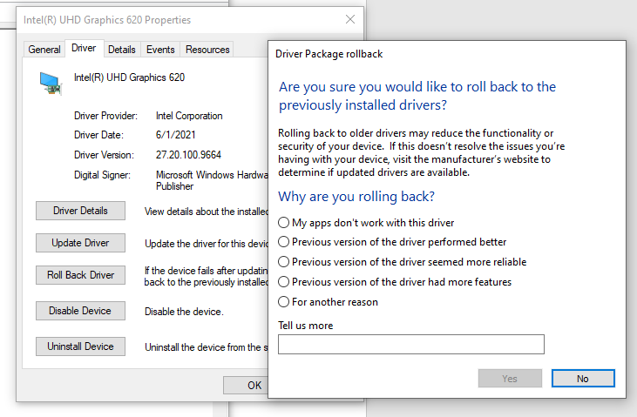

**Fix 7 – Unchecking services**

**Step 1:** For this fix you’ll need to go the system configuration.

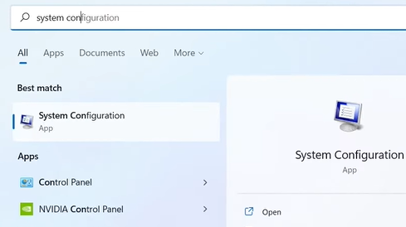

**Step 2:** In this window choose services. After that scroll down until you find problem reports control panel and windows error reporting service. Uncheck both of them and hit apply and restart your PC.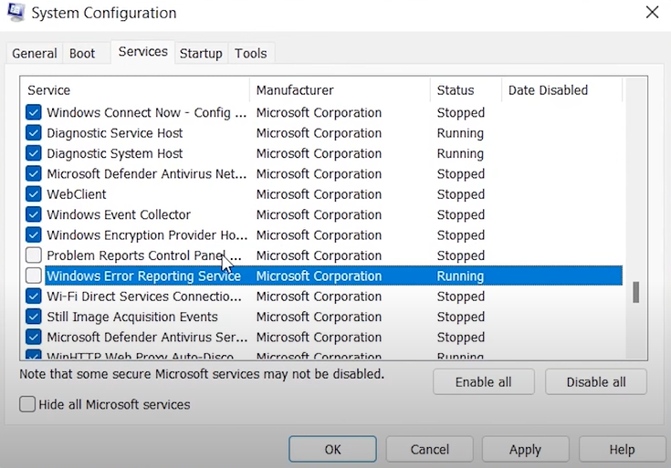

**FAQ**

**Is there a flickering screen issue on Windows 11?**

There are flickering issues on windows 11 due to incompatibility of display drivers with the PC or other issues. If you want to solve this problem, follow this article.

**What if the article fixes do not work for me?**

The article has covered most of the solutions. Even if your issue is not solved, the problem may lie with your display adapter. If it is, you might want to go to the nearest computer service center and change your display adapter.

**Will my data get deleted if I go to windows recovery?**

No, your data will not get deleted if you go to windows recovery mode. So, if used correctly, this mode can solve many issues. If you are unfamiliar with the windows recovery mode, do not play with it; instead, follow expert instructions like in this document.